

|  |
| --- |
|  |
| **Velocity Partner Marketing Guide**  **Functional Specifications Document** |
| |  |  | | --- | --- | | Program | EMC Partner | | DATE | 3/28/2013 | | Version | 2.2 | |

|  |
| --- |
| Table of Contents  Introduction 4  Overview 4  1 Main Page 5  1.1 User Interface 6  1.2 Annotations 7  2 Campaign Library 9  2.1 User Interface 10  2.2 Annotations 11  3 Campaign Detail Pages 12  3.1 User Interface 12  3.2 Annotations 13  4 Marketing Concierge Execution Packages 14  4.1 User Interface 14  4.2 Annotations 15  5 Distributor Programs 16  5.1 User Interface 17  5.2 Annotations 18  6 Media Packages 19  6.1 User Interface 19  6.2 Annotations 20  7 EMC Easy Street 21  7.1 User Interface 21  7.2 Annotations 22  8 Request Assistance 23  8.1 User Interface 23  8.2 Annotations 25  9 Terms and Conditions 27  9.1 User Interface 27  9.2 Annotations 28  10 Form Generated Emails 29  10.1 Acknowledgement Email 29  10.2 Request For Assistance Notification Email (to EMC Staff) 30  11 Non-Authenticated page 32  11.1 User Interface – without lightbox 33  11.2 User Interface – with Lightbox (default state) 34  11.3 Annotations 35  12 Non-Entitled Page 36  12.1 User Interface 36  12.2 Annotations 37  13 Assumptions, Dependencies, & Questions 38  13.1 Assumptions 38  13.2 Dependencies 38  13.3 Questions 38  14 Appendix 1 - Approved URL Structure 39  14.1 Existing URLs 39  14.2 New Site URLs 39  15 Appendix 2 - Entitlements 40  15.1 User Type Identifiers 40  15.2 Page Entitlements by User Types 40  15.3 Setting Page Entitlements by Identity and Program Tags (Set at the asset level) 41  16 Reference Documents 42  17 Document Change Log 43 |

# Introduction

## Overview

This document specifies the functional requirements and user interaction for the EMC Velocity Partner Marketing Guide (VPMG). The site is used by EMC Partners that are in the Velocity Marketing Program. They will use the site to navigate through various marketing materials being provided to them by EMC for the purposes of various marketing campaigns, distributor programs, and other informational material. The information is organized in a way that will allow users to gain access to contextually relevant PDF and ZIP files that contain the marketing materials (images, copy, other digital assets, etc.) All of this content will be presented in English, as well as localized into any number of languages relevant to the specific user.

# Main Page

The Main VPMG landing page is fairly straightforward, but as with the rest of the pages, it lives within the EMC.com framework of headers/footers.

The Portal page contains the following:

* Page Header †
* Uplink/Breadcrumbs †
* Carousel
* VPMG Navigation
* Content Pane
* Page Footer †

† - Denotes functional elements that are brought directly from emc.com – Specifically, the Page Header/Site Navigation, Uplink/Breadcrumbs below the Page header, and the Page Footer are all inherited from emc.com.

Page header will also house the link to manage the translation/localization of the page.

## User Interface



1

**No Feedback section**

6

4

5

3

2

## Annotations

|  |  |  |  |  |  |  |
| --- | --- | --- | --- | --- | --- | --- |
| # | | Label | | Description | Interaction | Source |
| 1 | **Page Header** | | Standard emc.com Global Header/Navigation – including the Uplink, Contact option, share option, and live chat option. | | Standard emc.com interaction  *Note: The link at the top that reads the name of your country will take user to the locale selector. When they change the locale, they will see the translated version of the VPMG site. It’s currently all in English, but the downloads will be in the selected language at launch. On a rolling basis the VPMG site content will also be translated as time/resources allow. Standard EMC.com Fallback logic applies.* | CMS |
| 2 | **Uplink** | | Standard emc.com behavior – Note, the text should read: “« Partners” (i.e. there should be a Guillemet in front of “Partners” – See: <http://en.wikipedia.org/wiki/Guillemet>)  Need to dig up info on Cufon display. Josh has details here. For double byte characters front end should use Cufon. | | Simple link – per standard emc.com uplink/breadcrumbs interaction protocols and style guide | - Title text comes from the Page Title attribute of Partner Landing Page on emc.com  - Link comes from and goes to the URL of the Partner Landing page on emc.com |
| 3 | **Carousel/Hero** | | Standard Carousel/Hero asset used across emc.com – the most recent implementation of which is the Newsroom Carousel – should mimic functionality of the Newsroom carousel exactly. | | Timed switching between the various “screens” as well as buttons allowing user to interact with the carousel and choose a specific “screen”  Hero area collapses and is replaced by Title text as soon as user navigates away from the “home” section. | Hero attributes defined in VPMG Hub – See Figure 1 below. |
| 4 | **VPMG Navigation** | | Site-specific navigation that keeps user experience consistent and within the confines of the VPMG site. Any clicks here will only change the what’s in the Content Pane (#5) | | Interaction should be the same as that of the EMC Newsroom navigation. This uses the Section Asset. | Home, Campaign Library, and Request Assistance come from Resource Bundle. Remaining items are in respective Section-Single Text asset or VPMG Distributor Asset for Distributor Programs link.  *Note: The Marketing Packages and Media Packages sections are optional*. |
| 5 | **Content Pane** | | This pane is what will change with different content throughout the site as the user uses the VPMG navigation (#4). | |  | For Home, Media, etc content will come from section assets associated to VPMG Hub. Campaigns will be retrieved dynamically from available VPMG Campaigns Assets.  The title of the section/page in this content pane is pulled from the same location as the left nav. They should match exactly except for the main landing page where the title reads Velocity Program Marketing Guide, but the link in the nav comes from the Resource Library “Home” |
| 6 | **Page Footer** | | Standard emc.com Global Footer | | Standard emc.com interaction | CMS Global Defaults |

Figure 1 - Hero Element and where text is sourced in VPMG Hub Asset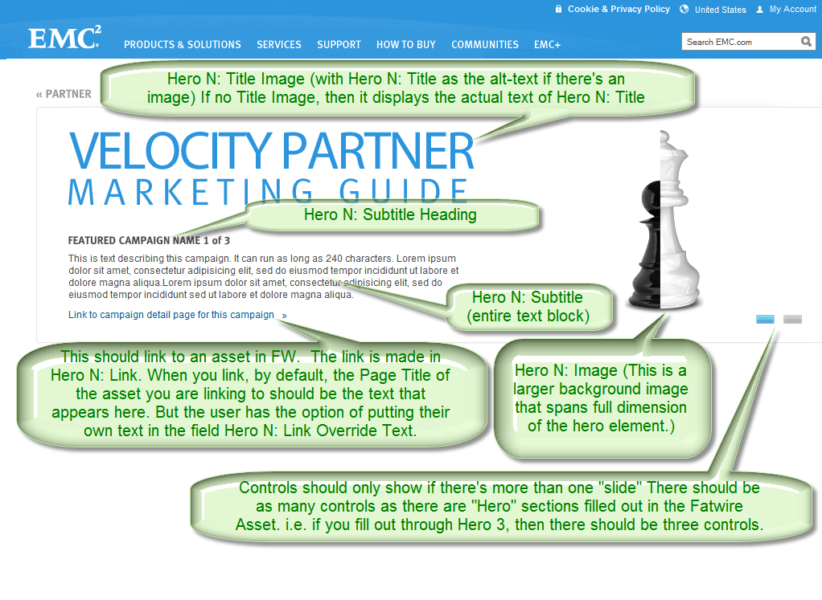

# Campaign Library

Like the Main Page, the Campaign Library page shares the same emc.com header/footer and VPMG site specific carousel. When the user clicks on the Campaign Library link in the VPMG navigation, they get the interface detailed below. The Navigation expands showing the user a series of checkboxes that correspond to various Campaign Topics that will be defined by the business. Clicking on those will curate the campaigns that appear in the content pane on the right. Additionally, the user can show the listing of campaigns sorted alphabetically, or by release date.

## User Interface



**No Feedback section**

1

2

4

3

## Annotations

|  |  |  |  |  |  |  |
| --- | --- | --- | --- | --- | --- | --- |
| # | | Label | | Description | Interaction | Source |
| 1 | **Campaign Topics Filter** | | Real-time filter that defaults to all options selected. User has the ability to leave only certain topics selected that are of interest to them. This will curate the list of campaigns that meet the topical criteria on the right side of the page. | | Checkboxes that when checked or unchecked update the content on the right. | Campaign Topics Taxonomy will drive what checkboxes appear here.  Campaign Topics are listed in VPMG Resource Bundle: CampaignTopic.A, CampaignTopic.B, CampaignTopic.C, CampaignTopic.D, CampaignTopic.E |
| 2 | **Sorting Dropdown** | | The listing of Campaigns will appear by default in reverse chronological order, with the most recent listed first. Selecting a different sort order from the dropdown will show the campaigns listed in the order chosen. | | Dropdown with two options:   * Alphabetical – will display campaigns in alphabetical order, ascending based on the Campaign Title. * By Release Date – displays campaigns in reverse chronological order (most recent, first) based on the Campaign Release Date | Regardless of sort order, only campaigns that are left visible based on the Campaign Topics filter (#1 above) will be sorted.  The Sorted fields for each campaign will be part of each Campaign dataset, either as part of the fatwire asset record, or some other source of readily accessible metadata. |
| 3 | **Campaign Record** | | Each Campaign will be exposed to the user in the form of a Campaign record which will contain a thumbnail (drawn from the first associated featured file in the Campaign Detail), the Campaign Title (up to 55 characters), and the Campaign Topic(s) associated with that campaign in the campaign detail data. (A Campaign can have one or more campaign topics associated) | | On Click – takes user to the Campaign Detail Page associated to the record they clicked on. Clicking anywhere on the record within the shaded area of each will link to the same place. (nothing else in that record will be separately linked anywhere besides the detail page) |  |
| 4 | **Library Listing** | | The listing of campaigns in this content pane will dynamically change the length of the entire page. (i.e. it will push down the footer so that it does not cover or otherwise affect the user’s ability to view and interact with any of the listed Campaign Records.) | | Scrolling will become active for the entire page when the bottom of the footer no longer fits in the browser window because the number of campaigns has pushed the footer too far down. |  |

# Campaign Detail Pages

Accessing a Campaign Detail Page will collapse the VPMG Navigation back to its original length (hiding the filtering mechanism visible on the Campaign Library Page). Additionally, the majority of the Campaign Details will be visible here. Possible not visible here, but necessarily stored as part of the metadata for each campaign (possible as part of the Fatwire Asset, or through some T3 tagging) are the Release Date and Campaign Topic.

## User Interface



**No Feedback section**

5

1

4

2

3

## Annotations

|  |  |  |  |  |  |  |
| --- | --- | --- | --- | --- | --- | --- |
| # | | Label | | Description | Interaction | Source |
| 1 | **Campaign Title** | | Up to 55 characters long. Also appears on Campaign Record in the Campaign Library. | | None | Campaign_Title from VPMG Campaign asset. |
| 2 | **Required Thumbnail** | | Thumbnail of primary asset associated with campaign. It is required because each campaign must have at least one asset associated with it beyond the content on the page below (#3) | | On Click – Will open popover window to download the digital asset (PDF file or Zip file). See Terms and Conditions below. | Featured File (collateral) associated to VPMG Campaign Asset. Thumbnail, title, download target sourced from Collateral |
| 3 | **Campaign Details Content** | | Freeform text that can be formatted by the web publisher with any textual information. | | If hyperlinks are included in the HTML, those may be clicked on and opened within a new browser window. | Body_Main content from VPMG Campaign Asset |
| 4 | **Optional Thumbnails** | | Thumbnail of additional secondary assets. | | On Click – Will open popover window to download the digital asset (PDF file or Zip file). See Terms and Conditions below. | Featured File associated to VPMG Campaign Asset (one, number 2 in this annotation is required. The rest are optional) |
| 5 | **Download Files** | | The language will depend on what locale the user is in (country selection in the header). | | Scrolling will become active for the entire page when the bottom of the footer no longer fits in the browser window because the number of campaigns has pushed the footer too far down.  On Click – Each link will correspond to a collateral asset. Clicking will open popover window to download the digital asset (PDF file or Zip file). See Terms and Conditions below. | Files (collateral) associated to VPMG Campaign asset via Related Items Child Asset List. |

# Marketing Concierge Execution Packages

Accessing the Marketing Concierge Execution Package will collapse the VPMG Navigation back to its original length (hiding the filtering mechanism visible on the Campaign Library Page if it happens to be visible, depending on where the user is when they navigate to it). Primarily this page will have some freeform content with images possibly. At the bottom of the page will be a link to some collateral for the user to download. Which collateral is displayed will be determined by the locale the user is navigating. As a result, if there is no file for their locale, this section can be hidden from them if the content author chooses. This section is not required.

## User Interface



**No Feedback section**

2

3

4

1

## Annotations

|  |  |  |  |  |  |  |
| --- | --- | --- | --- | --- | --- | --- |
| # | | Label | | Description | Interaction | Source |
| 1 | **VPMG Navigation** | | Collapsed view of the navigation with the current section that we’re in displayed in bold. | | Current Section – None  Other Sections –  On Click – navigate to the appropriate section. On Hover – Text becomes slightly darker – See behavior of Section Asset in use on a Product page like [Atmos Product Hub](http://www.emc.com/storage/atmos/atmos.htm#!details) | Fatwire Asset |
| 2 | **Section Header** | | Displays title of Current Section from Section Asset. | | None. | Section Label from Section-Single Text Asset. |
| 3 | **Section Content** | | Freeform text that can be formatted by the web publisher with any textual information. Including images. | | If hyperlinks are included in the HTML, those may be clicked on and opened within a new browser window. | Body_Main from Section- Single Text Asset |
| 4 | **Download Files** | | Verbiage says to “Select your location…” but that verbiage will likely change.  The file that appears here is associated in the Related Assets. The file associated will change based on Locale. | | On Click – Link corresponds with a locale-specific related asset. Clicking will open popover window to download the digital asset (PDF file or Zip file). See Terms and Conditions below. | Collateral associated to Section Asset. One asset for each domain (mapped to region)  Link Title comes from asset title if the Related_Content_Text_Override is not populated. Otherwise that field overrides the asset title. |

# Distributor Programs

The Distributor Programs page is essentially a specific type of campaign that has its own page accessible directly from the VPMG Navigation. Navigating to it displays the collapsed view of the VPMG Navigation. Since this is largely a campaign page, with some slight nuances, we hope to be able to leverage the Campaign Detail Page with some layout tweaks to display it.

There will be a free form area with an image displayed. This image is not a thumbnail from any digital asset, so it will be added by the content editors when they create the page. User will see list of files available for download in a chosen language. Selecting a different language will refresh the page and display potentially different links.

Content Editor will also be able to assign a category and manage where related collateral files appear on the page (i.e. Under which category like “Sales Tools” etc.) – Content Editor can also choose to exclude this section from the page for a particular locale. (optional section)

**Additionally, this entire section is conditional in that it is only visible to users who have a Program tag of “Distributor” set ONLY.**

## User Interface

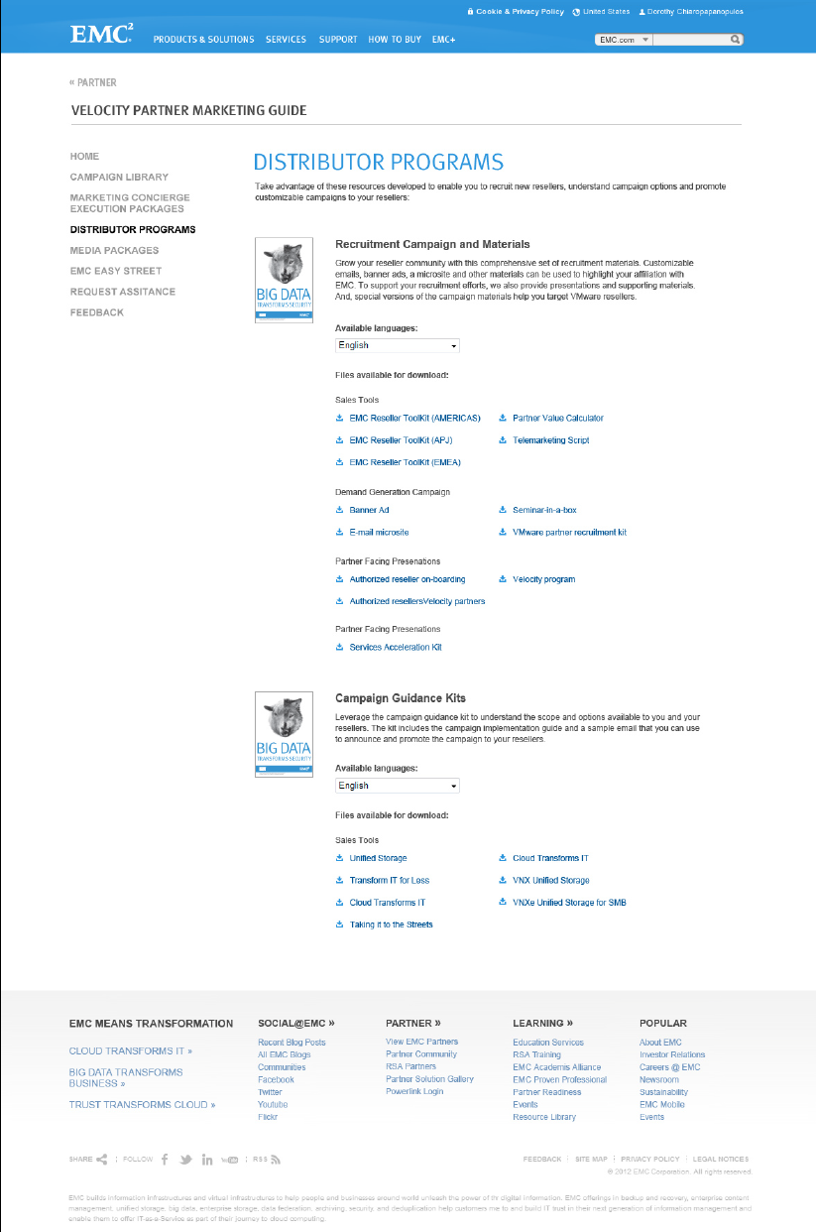

**No Feedback section**

4

4

2

3

1

## Annotations

|  |  |  |  |  |  |  |
| --- | --- | --- | --- | --- | --- | --- |
| # | | Label | | Description | Interaction | Source |
| 1 | **VPMG Navigation** | | Collapsed view of the navigation with the current section that user is in displayed in bold.   **Note: If a user does not have the Distributor Program tag in their user profile, they will not see the Distributor Programs section appear in their navigation.** | | Current Section – None  Other Sections –  On Click – navigate to the appropriate section. On Hover – Text becomes slightly darker – See behavior of Section Asset in use on a Product page like [Atmos Product Hub](http://www.emc.com/storage/atmos/atmos.htm#!details) | Fatwire Asset |
| 2 | **Section Header** | | Displays title of Current Section from Section Asset. | | None. | Section Label from Section-Single Text Asset. |
| 3 | **Section Content** | | Freeform text that can be formatted by the web publisher with any textual information. Including images. | | If hyperlinks are included in the HTML, those may be clicked on and opened within a new browser window. | Body_Main from Section- Single Text Asset |
| 4 | **Download Files** | | The language of the download files will depend on what locale the user is in (country selection in the header). | | On Click – Each link will correspond to a digital collateral asset. Clicking will open popover window to download the digital asset (PDF file or Zip file). See Terms and Conditions below. | Collateral associated to Section Asset. Collateral is also assigned a topic via VPMG Distributor asset.  Title comes from Collateral asset title. |

# Media Packages

The Media Packages page is almost a combination of a Distributor Program page and a Marketing Concierge Execution Package page. They layout is akin to the former, with the curation of available downloads mimicking that of the latter.

There will be a free form area with an image displayed. This image is not a thumbnail from any digital asset, so it will be added by the content editors when they create the page. At the bottom of the page will be a link to some collateral for the user to download. Which collateral is displayed will be determined by the locale the user is navigating. As a result, if there is no file for their locale, this section can be hidden from them if the content author chooses. This section is not required.

## User Interface

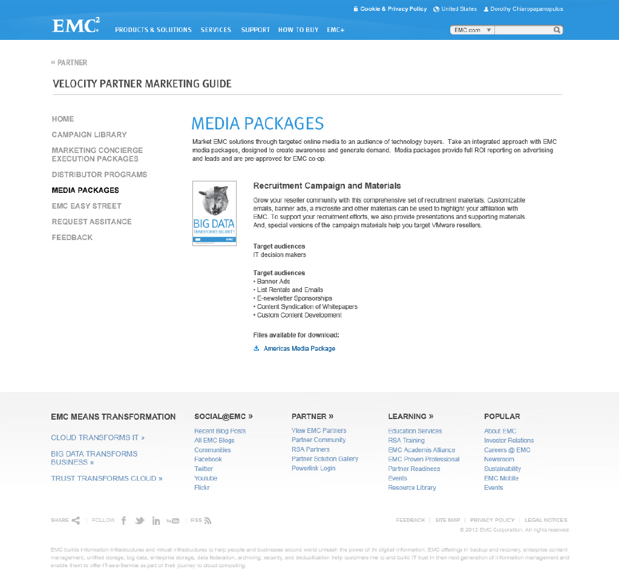

**No Feedback section**

2

3

4

1

## Annotations

|  |  |  |  |  |  |  |
| --- | --- | --- | --- | --- | --- | --- |
| # | | Label | | Description | Interaction | Source |
| 1 | **VPMG Navigation** | | Collapsed view of the navigation with the current section that user is in displayed in bold. | | Current Section – None  Other Sections –  On Click – navigate to the appropriate section. On Hover – Text becomes slightly darker – See behavior of Section Asset in use on a Product page like [Atmos Product Hub](http://www.emc.com/storage/atmos/atmos.htm#!details) | Fatwire Asset |
| 2 | **Section Header** | | Displays title of Current Section from Section Asset. | | None. | Title from Section Asset. |
| 3 | **Section Content** | | Freeform text that can be formatted by the web publisher with any textual information. Including images. | | If hyperlinks are included in the HTML, those may be clicked on and opened within a new browser window. | Body from Section Asset |
| 4 | **Download Files** | | The language of the download files will depend on what locale the user is in (country selection in the header).  File that appears here for download will be curated based on the user’s locale. As in Marketing Concierge Execution Packages. | | On Click – Link corresponds with a geo-specific digital asset. Clicking will open popover window to download the digital asset (PDF file or Zip file). See Terms and Conditions below. | Collateral associated to Section Asset. Either one asset for each domain (mapped to region) or translations of an asset.  Title comes from asset or can be overridden by Related_Content_Text_Override field in the Section asset. |

# EMC Easy Street

EMC Easy Street page simply displays some verbiage and a link to EMC Easy Street. (Separate site)

## User Interface

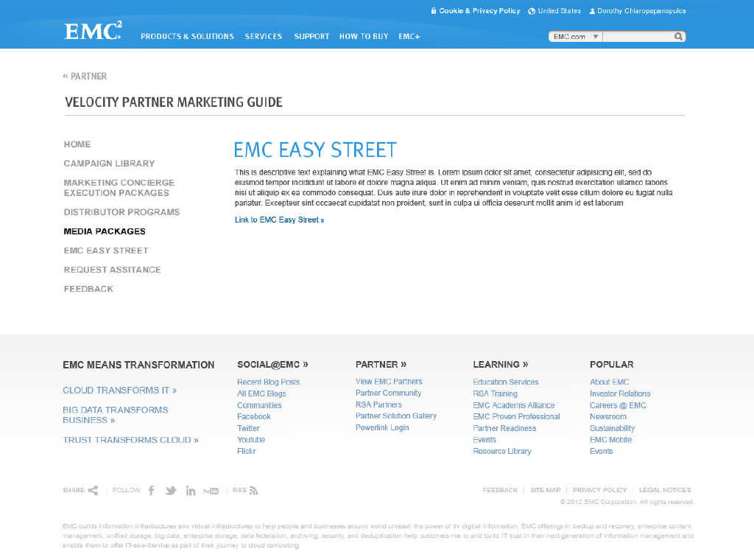

**No Feedback section**

2

3

1

## Annotations

|  |  |  |  |  |  |  |
| --- | --- | --- | --- | --- | --- | --- |
| # | | Label | | Description | Interaction | Source |
| 1 | **VPMG Navigation** | | Collapsed view of the navigation with the current section that user is in displayed in bold. (not shown here) | | Current Section – None  Other Sections –  On Click – navigate to the appropriate section. On Hover – Text becomes slightly darker – See behavior of Section Asset in use on a Product page like [Atmos Product Hub](http://www.emc.com/storage/atmos/atmos.htm#!details) | Fatwire Asset |
| 2 | **Section Header** | | Displays title of Current Section from Section Asset. | | None. | Section Label from Section-Single Text Asset. |
| 3 | **Section Content** | | Freeform text that can be formatted by the web publisher with any textual information. Including images. | | If hyperlinks are included in the HTML, those may be clicked on and opened within **a new browser window.** | Body_Main from Section- Single Text Asset |

# Request Assistance

User would utilize this page to request assistance with the site or with a specific campaign. It is differentiated from the Feedback page by the fact that in this instance, a user would anticipate a response from the VPMG team.

## User Interface

Form Interface:

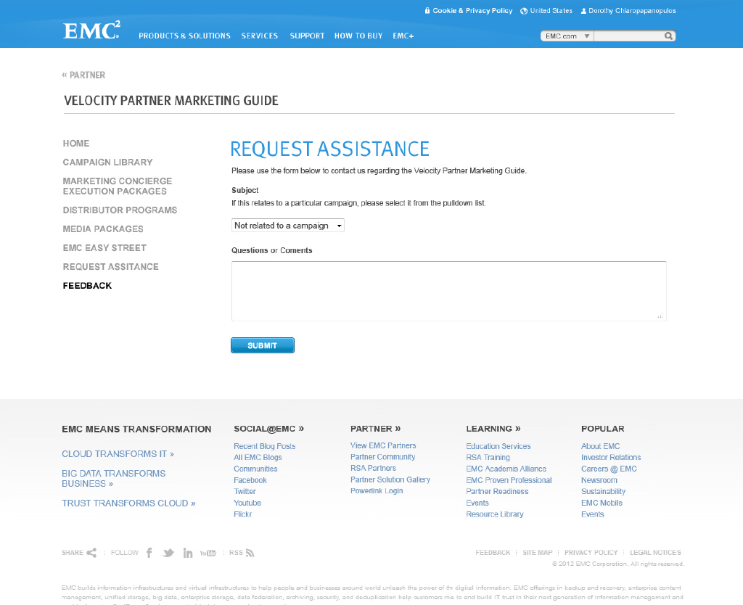

**No Feedback section**

4

3

2

1

Successful submission Form Interface:

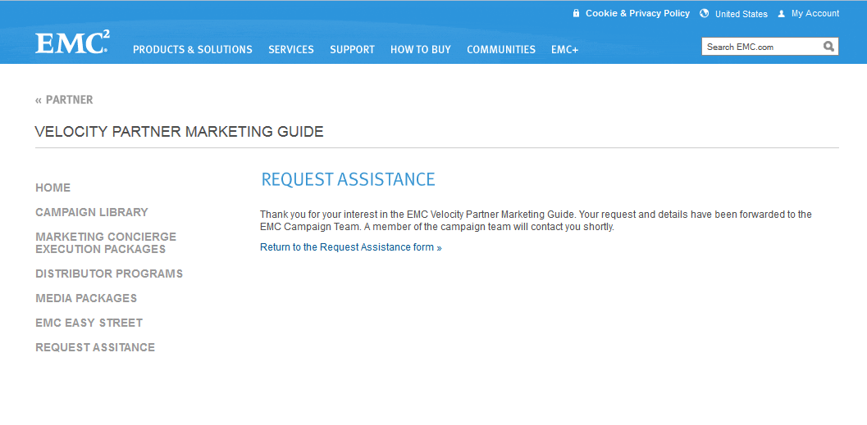

**No Feedback section**

Error Messaging:

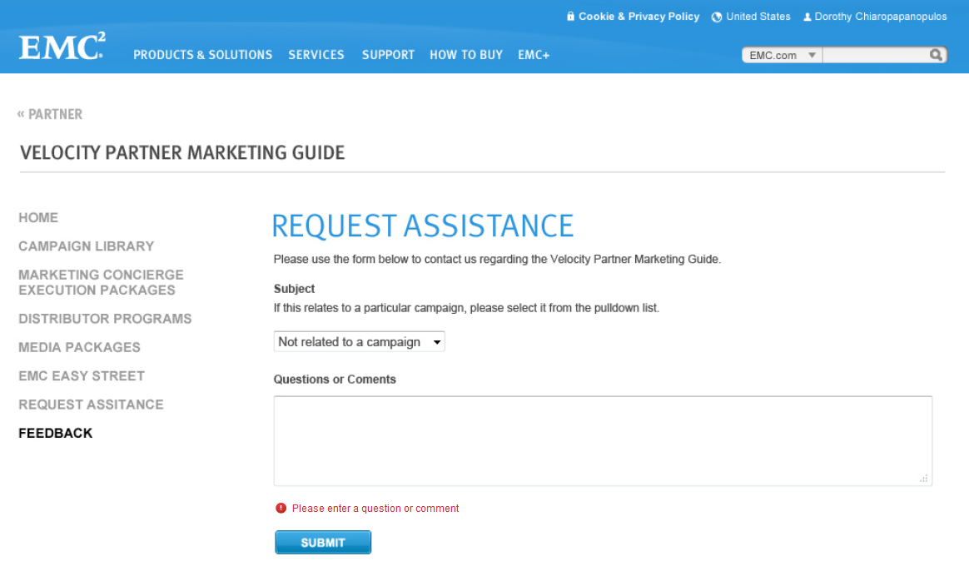

**No Feedback section**

## Annotations

6

5

|  |  |  |  |  |  |  |
| --- | --- | --- | --- | --- | --- | --- |
| # | | Label | | Description | Interaction | Source |
| 1 | **VPMG Navigation** | | Collapsed view of the navigation with the current section that user is in displayed in bold. | | Current Section – None  Other Sections –  On Click – navigate to the appropriate section. On Hover – Text becomes slightly darker – See behavior of Section Asset in use on a Product page like [Atmos Product Hub](http://www.emc.com/storage/atmos/atmos.htm#!details) | Fatwire Asset |
| 2 | **Section Header** | | Displays title of Current Section from Section Asset. | | None. | Title from VPMG Resource Bundle. |
| 3 | **Section Content** | | Freeform instructional text that can be formatted by the web publisher with any textual information. Including images. | | If hyperlinks are included in the HTML, those may be clicked on and opened within a new browser window. | Body from VPMG Resource Bundle |
| 4 | **Form Elements** | | Dropdown asks user to identify the type of assistance they require (i.e. is it related to a campaign). Following the dropdown they would simply enter their question or comment in the free text field. | | Dropdown – User selects either “Not related to a campaign” (Default) or chooses one from the list of campaigns. Also listed separate from the campaigns are “Marketing Concierge Execution Packages”, “Distributor Programs”, “Media Packages”, and “EMC Easy Street” - The latter should be listed below the full list of campaigns.  Freetext – User can enter any acceptable text, following standard EMC practices for web forms.  Submit – On Click will send email with the contents of the form to a number of people based on certain business rules that hinge on the user’s geography to determine who gets copied on that email. Additionally, sends confirmation email to user.  Validation – Check that user entered text in comments field. (i.e. field is non-blank). Error messaging as shown above in third image. | Dropdown choices from VPMG Resource Bundle and from Page Title of Campaign Detail assets that are active.  Submit button text from VPMG Resource Bundle             Error message from VPMG Resource Bundle |
| 5 | **Success Messaging** | | When user successfully submits a Request Assistance display this messaging. | | None | Text from VPMG Resource Bundle |
| 6 | **Link back to Request Assistance Form** | | Link returns user to the request assistance form in the event they want to submit another request. | | On Click – return user to blank Request Assistance form – same behavior as if they had clicked on the Request Assistance link in the left Navigation | Text from VPMG Resource Bundle |

# Terms and Conditions

Each time a user clicks on a download link, they are presented with this lightbox with Terms and Conditions. A user must agree to them before they can download any file every time. If they download one file 200 times, they must agree to the Terms and Conditions 200 times. If they download 200 files once, again – they need to agree to the Terms and Conditions every time.

## User Interface

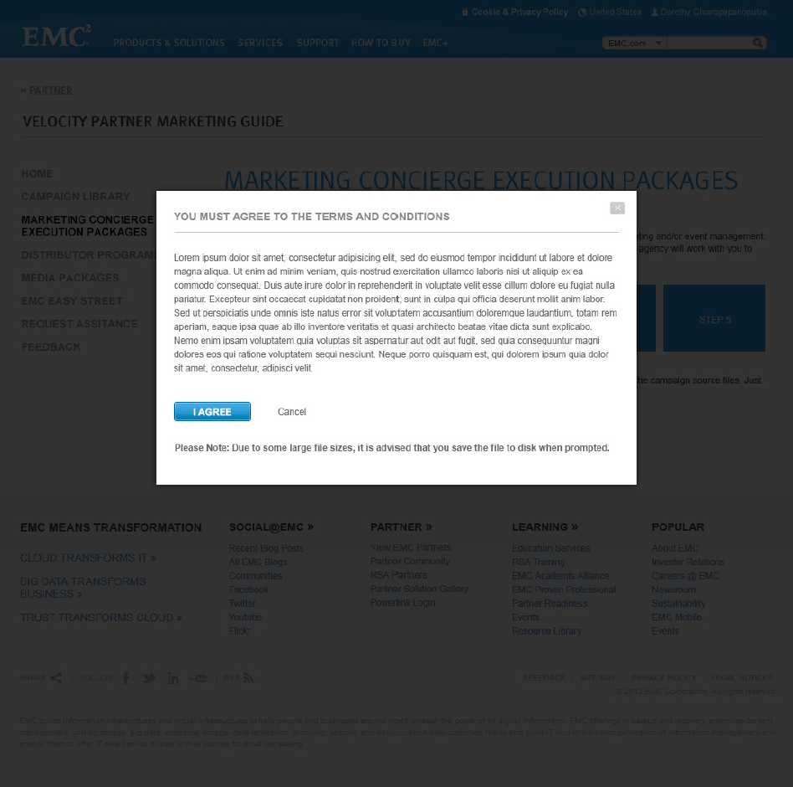

3

2

1

3

## Annotations

|  |  |  |  |  |  |  |
| --- | --- | --- | --- | --- | --- | --- |
| # | | Label | | Description | Interaction | Source |
| 1 | **Terms and Conditions Lightbox** | | Describes terms and conditions. Verbiage is identical for all files and file types. | | None | VPMG Resource Bundle – TermsAndConditions.Header, TermsAndConditions.Terms, and TermsAndConditions.LargeFileWarning |
| 2 | **Agree/Cancel Control** | | User must agree or cancel to move on. | | I Agree – On Click will close lightbox and begin downloading the file in question.  Cancel – On Click will close lightbox and no files will download. Returns user to the page that they were on when they invoked the download. | VPMG Resource Bundle – TermsAndConditions.AgreeButton and TermsAndConditions.CancelLink |
| 3 | **Close lightbox** | | Icon closes lightbox without agreeing to Terms and Conditions. This is same behavior as clicking on Cancel link. | | On Click – Same as Cancel link above in #2 | CMS |

# Form Generated Emails

The output from Request Assistance form generates a series of emails. One email is an acknowledgement that is sent to the user who submitted the request. The second type of message is the request for assistance that goes to the EMC users.

## Acknowledgement Email

Subject : Implementation requested for “<**Campaign Name**>” campaign  
**OR**  
Subject : Implementation requested for **no specific** campaign  
From:< **EMC**>  
To: <**VPMG User’s email address**>

Dear<**VPMG User’s First Name**> <**VPMG User’s Last Name**>  
  
Thank you for submitting your enquiry interest in the “<**Campaign Name**>” Campaign, from the Velocity Powered Campaigns web portal.   
  
---------------------------------------------------------------------------------------------------------------  
  
Enquiry Reference : <**Request Identifier**>  
  
---------------------------------------------------------------------------------------------------------------  
  
We will contact you as soon as we can to assist you in the implementation. However if you need to contact us further with regards to your query, please quote the reference <**Request Identifier**>.  
  
Kind Regards,  
  
Emc Velocity Powered Campaigns Team  
  
Your Details :  
  
First Name : <**VPMG User’s First Name**>  
Last Name : <**VPMG User’s Last Name**>  
Email : <**VPMG User’s email address** >  
Country : <**Country**>  
Company Name : <**Partner Company Name**>  
Company Address1 : <**Partner Company Address1**>  
Company Address2 : <**Partner Company Address2**>  
Company City : <**Partner Company City**>  
Company State : <**Partner Company State**>  
Company ZIP : <**Partner Company PostalCode**>  
  
  
  
Additional Comments :  
  
---------------------------------------------------------------------------------------------------------------  
  
<**Comments**>  
   
---------------------------------------------------------------------------------------------------------------

Note: <RequestIdentifier> is to be populated with the UUID of the request. It should match that listed in the email to the EMC Staff (from 10.2).

## Request For Assistance Notification Email (to EMC Staff)

Subject : Implementation guidance requested for “<**Campaign Name**>” campaign  
**OR**  
Subject : Implementation guidance requested for **no specific** campaign  
From:< **EMC**>  
To: MParsons, Deb ‎[deb.parsons@emc.com]‎   
Cc: MGlobal Demand Programs ‎[Global_Demand_Programs@emc.com]‎

Query ref : <**Request Identifier**>  
  
Message received from Velocity Powered Campaigns web portal :  
  
Partner Details :  
  
First Name : <**VPMG User’s First Name**>  
Last Name : <**VPMG User’s Last Name**>  
Email : <**VPMG User’s email address** >  
Country : <**Country**>  
Company Name : <**Partner Company Name**>  
Company Address1 : <**Partner Company Address1**>  
Company Address2 : <**Partner Company Address2**>  
Company City : <**Partner Company City**>  
Company State : <**Partner Company State**>  
Company ZIP : <**Partner Company PostalCode**>  
  
  
  
Additional Comments :  
  
---------------------------------------------------------------------------------------------------------------  
  
<**Comments**>  
   
---------------------------------------------------------------------------------------------------------------

Note: <RequestIdentifier> is to be populated with the UUID of the request. It should match that listed in the email to the user (from 10.1).

# Non-Authenticated page

This page comes up when a user is not logged in and attempts to access any VPMG page or any of the download files (i.e. if they are deep linking) The page follows the same general structure of the rest of the VPMG pages with the same header/footer with some of the content coming from the VPMG Hub Asset and some from VPMG Messages resource bundles. There is NO VPMG navigation visible. By default, the page opens with the Login lightbox/overlay on top of it. (Section 11.2) but if the user cancels out of the lightbox they would see the page as it appears in Section 11.1.

## User Interface – without lightbox

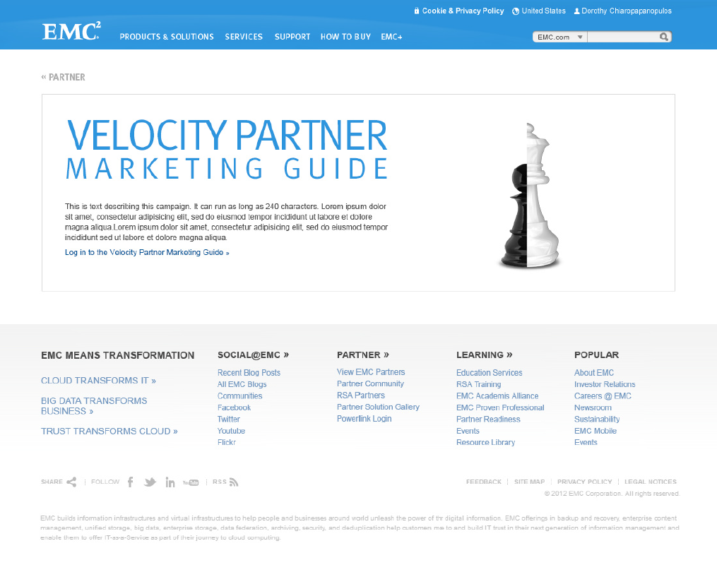

3

2

1

## User Interface – with Lightbox (default state)

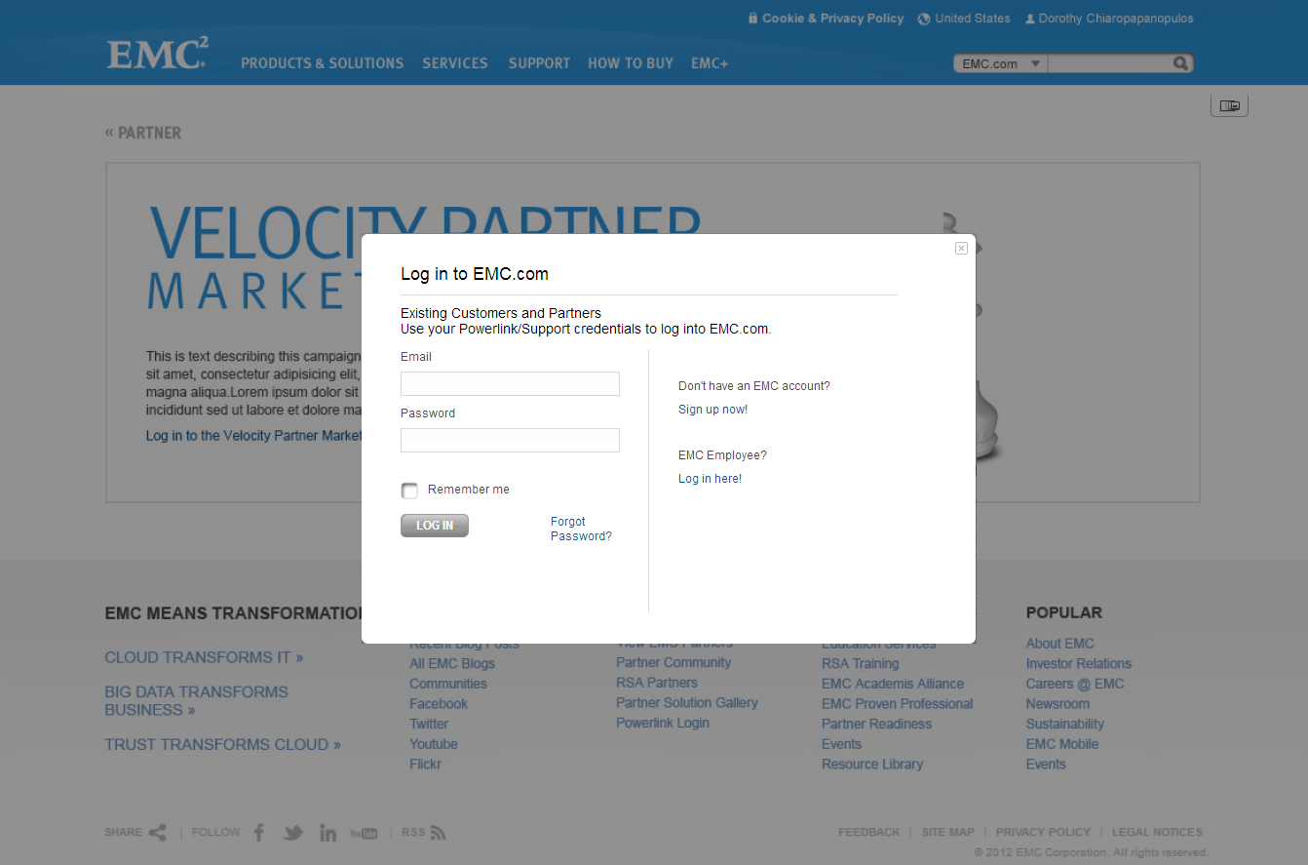

4

5

## Annotations

|  |  |  |  |  |  |  |
| --- | --- | --- | --- | --- | --- | --- |
| # | | Label | | Description | Interaction | Source |
| 1 | **Non-Authenticated Section** | | Background Image with stylized Page Title similar to the Hero on the Hub page. | | None | VPMG Hub Page Title |
| 2 | **Abstract** | | Brief text block describing VPMG | | None | VPMG Hub Body_Abstract |
| 3 | **Call To Action** | | Link opens the Login Lightbox | | On Click opens Login Lightbox overlayed on top of this page. | VPMG Messages Resource Bundle: NonAuthenticated.LinkTitle |
| 4 | **Login Overlay** | | This overlay should behave exactly like the standard EMC.com login overlay. It only appears over the non-authenticated page, no matter what the user was attempting to access. One link is different (below) | | Same as standard EMC.com login screen, aside from the two exceptions below. |  |
| 5 | **Link to Register** | | In THIS version of the login, the link title is the same, but the URL must take user to Powerlink Registration. | | On Click, open new tab and take user to Powerlink Registration page. | URL = https://sso.emc.com/registration/register.htm |

# Non-Entitled Page

This page comes up when a user is logged in but does not have permissions or entitlements to see the page they are trying to access. The page follows the same general structure of the rest of the VPMG pages with the same header/footer with content coming from the VPMG Messages resource bundles. The Navigation that is visible is only that which the user can see. In the case of a Velocity Partner who attempts to access the Distributor Program page (for example if someone sent it to them) they would see this page, with the navigation showing the other VPMG pages. (in that case “Distributor Programs” would not appear as it does on the comp below).

## User Interface

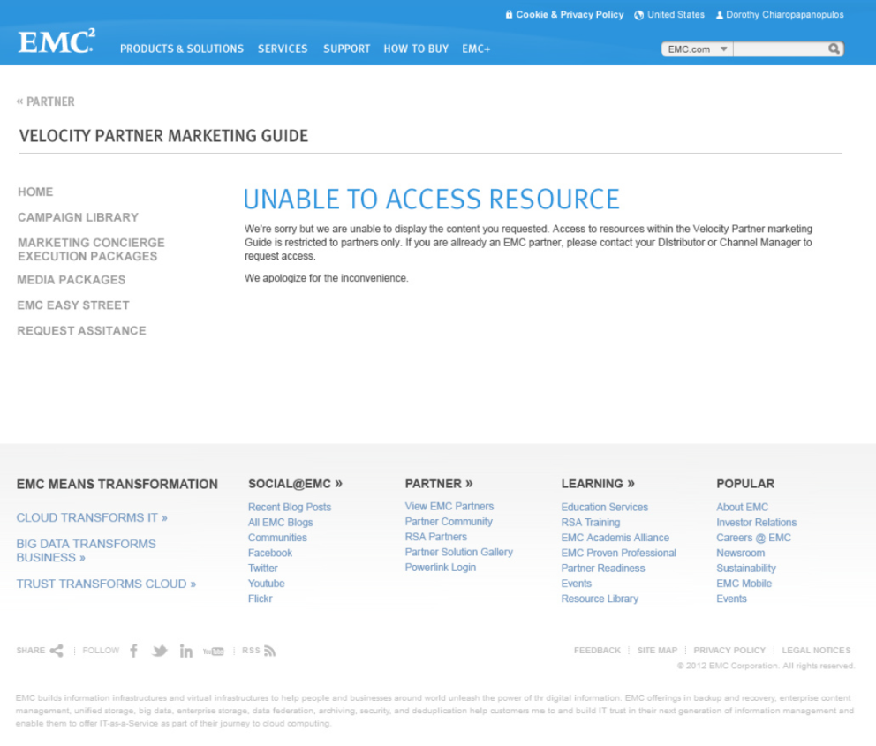 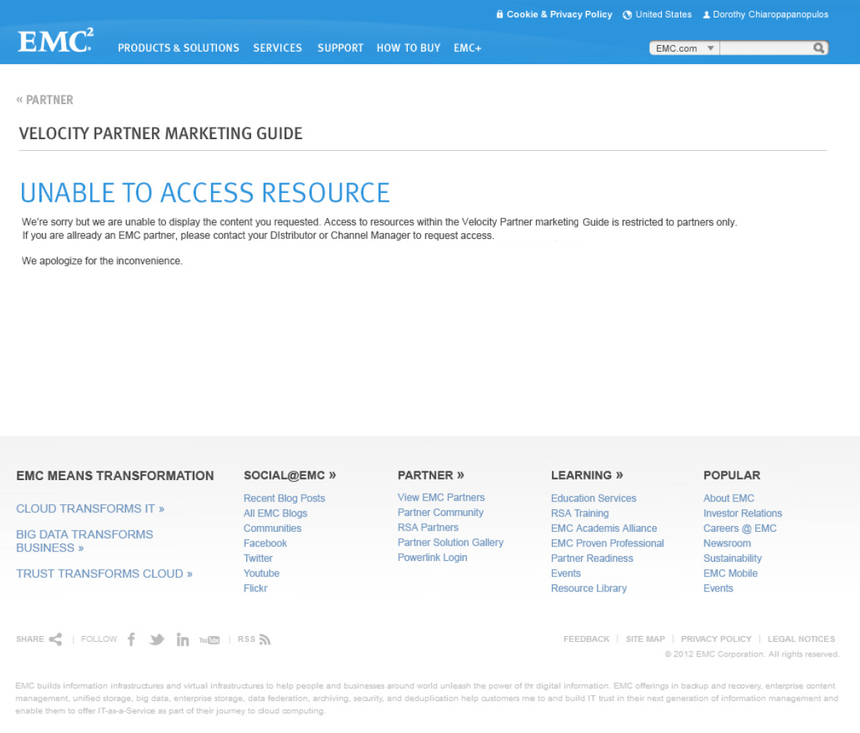

2

3

2

1

3

## Annotations

|  |  |  |  |  |  |  |
| --- | --- | --- | --- | --- | --- | --- |
| # | | Label | | Description | Interaction | Source |
| 1 | **VPMG Navigation** | | Navigation should show only what user has access to. For MOST users who don’t have access to ANY part of the VPMG, then this would not appear at all. The only use case where something appears is if a user tries to access a Distributor Program page from a link or a bookmark and is not a distributor. They would get the message in #2/3 below, but they would be able to navigate to the rest of the VPMG site. | | Same as the Navigation (#4) in Section 1 | Same as the Navigation (#4) in Section 1 |
| 2 | **Title** | | Page Title | | None | VPMG Messages Resource Bundle “NonEntitled.Title” |
| 3 | **Description** | | Description | | None | VPMG Messages Resource Bundle “NonEntitled.Desc” |

Note: See VPMG Login Flow document listed in Reference Documents for more information.

# Assumptions, Dependencies, & Questions

## Assumptions

1. Terms and Conditions verbiage will be identical for all files, file types.
2. Any form data entered by the user is sent via email only, it is only stored in a log file, but nowhere else in the CMS or a db.
3. Thumbnails in Campaign Detail pages are uploaded from a content creator’s desktop and are associated with each piece of collateral. (i.e. Zip File, PDF, etc.)
4. The Thumbnail in the Campaign Library is the first one that is visible on the Campaign Detail page for that campaign. At least one thumbnail would be required. If this is not the case, we will need a default thumbnail to use in the event a user doesn’t upload a thumbnail and associate it with the downloadable files.
5. The VPMG Site is not to be searched via the EMC.com global search (top nav)
6. VPMG Content is not to appear in the EMC.com Resource Library
7. The VPMG Site is not to appear in public search engines (i.e. Google, Bing, etc.) We need to take steps to ensure that pages are not indexed, although the fact that they are entitled likely will ensure they won’t be.
8. Employees of all types will be granted access to VPMG, a more granular distinction around types of employees will not be made.
9. It is possible to have non-Velocity Distributors. We must take that into account so that only Velocity Distributors can see VPMG.
10. Collateral files under 20MB are to be uploaded by content editors to Fatwire from the New Collateral Asset function.
11. Collateral files over 20MB are to be uploaded to Syncplicity by James Young. She will provide the URL of the file to content editors, which will then enter the URL into the External URL field of the Collateral asset in the New Collateral Asset function in Fatwire.
12. All pages except Campaign Detail pages will inherit their Metadata from the VPMG Hub.
13. Campaign Detail Pages will have the ability for the Content Editors to set their own metadata.

## Dependencies

## Questions

# Appendix 1 - Approved URL Structure

## Existing URLs

Currently there are two URLs that exist for the VPMG site.

|  |  |  |
| --- | --- | --- |
| URL | Current State | Post-Launch State |
| <https://velocitycampaigns.acorndesign.co.uk> | Current home of VPMG Site hosted by Acorn Design, UK. | Business to work with Acorn to implement a redirect to location of new site. |
| <http://www.emc.com/velocitymarketingguide> | Currently redirects to the Acorn.co.uk domain to the current site. | UW team to facilitate communication with EMC Middleware team to change URL to redirect to new VPMG URL. |

## New Site URLs

|  |  |  |
| --- | --- | --- |
| VPMG Page/Section | URL | Hard Coded |
| VPMG Hub Page (Landing Page) | http://www.emc.com/secure/partnerships/campaigns/index.htm |  |
| Campaign Library | http://www.emc.com/secure/partnerships/campaigns/library.htm | * |
| Campaign Detail Pages | http://www.emc.com/secure/partnerships/campaigns/<short campaign name>.htm |  |
| Campaign Collateral | http://www.emc.com/secure/collateral/<classification-path>/<filename> |  |
| Marketing Concierge Execution Packages | http://www.emc.com/secure/partnerships/campaigns/index.htm#!marketingconcierge |  |
| Marketing Concierge Collateral | http://www.emc.com/secure/collateral/<classification-path>/<filename> |  |
| Distributor Programs | http://www.emc.com/secure/partnerships/campaigns/distributor.htm |  |
| Distributor Collateral | http://www.emc.com/secure/distributor-collateral/<filename> |  |
| Media Packages | http://www.emc.com/secure/partnerships/campaigns/index.htm#!mediapackages |  |
| Media Package Collateral | http://www.emc.com/secure/collateral/<classification-path>/<filename> |  |
| EMC Easy Street | http://www.emc.com/secure/partnerships/campaigns/index.htm#!easystreet |  |
| Request Assistance | http://www.emc.com/secure/partnerships/campaigns/help.htm | * |
| Images | http://www.emc.com/secure/partnerships/images/<filename> |  |
| Non-Entitled Page | http://www.emc.com/secure/partnerships/campaigns/access-required.htm | * |
| Non-Authenticated Page | http://www.emc.com/partnerships/campaigns/login-required.htm | * |

# Appendix 2 - Entitlements

## User Type Identifiers

|  |  |  |
| --- | --- | --- |
| User Type | Identity | MUP Attributes |
| Velocity Partners | Partner | emcPartnerProgram = "Velocity Program" |
| Velocity Distributors | Partner | emcPartnerProgram = "Velocity Program"  **AND**  emcPartnerBusinessModel = "Distributor" |
| Employees | Employee (E, V, and T users identified via Authentication mechanism) | Any |

## Page Entitlements by User Types

|  |  |
| --- | --- |
| Page | User Type with access |
| VPMG Hug Landing Page | Velocity Partners, Velocity Distributors, Employees |
| Campaign Library | Velocity Partners, Velocity Distributors, Employees |
| Campaign Detail Page (All) | Velocity Partners, Velocity Distributors, Employees |
| Campaign Detail Collateral (All) | Velocity Partners, Velocity Distributors, Employees |
| Marketing Concierge Execution Package | Velocity Partners, Velocity Distributors, Employees |
| Marketing Concierge Execution Package Collateral (All) | Velocity Partners, Velocity Distributors, Employees |
| Distributor Programs | Velocity Distributors, Employees |
| Distributor Program Collateral (All) | Velocity Distributors, Employees |
| Media Packages | Velocity Partners, Velocity Distributors, Employees |
| Media Packages Collateral (All) | Velocity Partners, Velocity Distributors, Employees |
| EMC Easy Street | Velocity Partners, Velocity Distributors, Employees |
| Request Assistance | Velocity Partners, Velocity Distributors, Employees |

## Setting Page Entitlements by Identity and Program Tags (Set at the asset level)

|  |  |  |
| --- | --- | --- |
| Page | Identity Tag | Program Tag |
| VPMG Hug Landing Page | Partner | Velocity |
| Campaign Library | Partner | Velocity |
| Campaign Detail Page (All) | Partner | Velocity |
| Campaign Detail Collateral (All) | Partner | Velocity |
| Marketing Concierge Execution Package | Partner | Velocity |
| Marketing Concierge Execution Package Collateral (All) | Partner | Velocity |
| Distributor Programs | Partner | Velocity  Distributor |
| Distributor Program Collateral (All) | Partner | Velocity  Distributor |
| Media Packages | Partner | Velocity |
| Media Packages Collateral (All) | Partner | Velocity |
| EMC Easy Street | Partner | Velocity |
| Request Assistance | Partner | Velocity |

# Reference Documents

|  |  |
| --- | --- |
| Document | Description |
| <https://eperoom01.emc.com/nsepn/webapps/ikrv5596hzk1712/eRoom/partners/EMCNGOEPhase2Project/0_68a75> | This document. Always access the version with the highest number. Func_Spec_EMC VPMG_v2.2.doc |
| <https://eperoom01.emc.com/nsepn/webapps/ikrv5596hzk1712/eRoomReq/Files/partners/EMCNGOEPhase2Project/0_7464e/uw_asset_model_notes_vSprint206_SM.xls> | Fatwire Asset Model Notes. Always access the version with highest Sprint number. |
| <https://eperoom01.emc.com/nsepn/webapps/ikrv5596hzk1712/eRoomReq/Files/partners/EMCNGOEPhase2Project/0_7445a/VPMG%20Login%20Flow.docx> | Description of login flow for VPMG users. |
| <https://eperoom01.emc.com/nsepn/webapps/ikrv5596hzk1712/eRoomReq/Files/partners/EMCNGOEPhase2Project/0_74990/VPMG%20URLs_Final.xlsx> | Final URL Notes |
| <http://137.69.172.177/adam/wires_vpmg_v01/index.html> | Wireframes for VPMG site incorporated into EMC.com framework. |
| <https://eperoom01.emc.com/nsepn/webapps/ikrv5596hzk1712/eRoomReq/Files/partners/EMCNGOEPhase2Project/0_74991/VPMG%20Download%20Types%20and%20Classification%20Path%20for%20Collateral%20URLs.xlsx> | Document Type to Classification Path Mapping for Collateral URLs |
| <https://eperoom01.emc.com/nsepn/webapps/ikrv5596hzk1712/eRoomReq/Files/partners/EMCNGOEPhase2Project/0_74992/VPMG%20High%20Level%20Test%20Plan_v1.0.docx> | High Level Test Plan – provided to TCOE |

# Document Change Log

| Version | Description | Date | Author |
| --- | --- | --- | --- |
| 1.0 | Initial Document | 11/19/2012 | R. Reimundez |
| 1.1 | Fleshed out remaining sections | 12/26/2012 | R. Reimundez |
| 1.2 | Fleshed out remaining sections and included outstanding questions. | 1/16/2013 | R. Reimundez |
| 1.3 | Solidified list of questions – reserve the right for more questions later. | 1/17/2013 | R. Reimundez |
| 1.4 | Incorporated responses from Adam F. and Janet B. | 1/23/2013 | R. Reimundez |
| 1.5 | Additional clarifications | 1/29/2013 | R. Reimundez |
| 1.6 | Revision | 2/1/2013 | R. Reimundez |
| 1.7 | Revised with Form Success screens | 2/15/2013 | R. Reimundez |
| 1.8 | Revised to eliminate language dropdowns, feedback form, etc. | 2/26/2013 | R. Reimundez |
| 1.9 | Section 1 – Add the use of emc.com translation mechanism and fallback logic for site and all related collateral assets (downloads)  Sections 3 & 5 – Remove mention of language dropdowns.  Sections 4 & 6 – Use emc.com fallback mechanism for geo-specific content  Sections 4 & 6 – Cover hiding sections from hub page certain locales as needed.  Marketing Packages and Media Packages are going to be Not Required. By default, pull in title… In asset allow override. Related Content Text Override  Section 5 - Distributor spec update – make section conditional on entitlement. Asset model change to add Distributor  Section 9 – Feedback Form – Remove altogether – Renumber subsequent sections.  Section 11 & 12 – Completed sections for Non-Authenticated Page/Login screen and Non-Entitled Page | 3/1/2013 | R. Reimundez |
| 2.0 | Section 8 – Addition of Form validation and error messaging.  Also updated Resource Bundle  All Sections – Added note to comps reminding that there’s no Feedback Form  Section 1.2 – Added figure showing source of text for Hero Element  Section 11 – Removed requirement to change the Forgot Password link.  Section 13.1 – Added Assumptions 5, 6 & 7 – regarding Search  Section 13.1 – Added Assumption 8 – Employee access  Section 13.1 – Added Assumption 9 – calling out non-velocity distributors  Added Section 14 for URL Structure. | 3/15/2013 | R. Reimundez |
| 2.1 | Section 12 – Updated screenshots and annotation for Non-Entitled Pages  Reference Documents – Added VPMG Login Process Flow document.  Section 13.1 – Added Assumption 10 – Collateral under 20mb  Section 13.1 – Added Assumption 11 – Collateral over 20mb  Section 13.1 – Added Assumption 12 – Metadata Inheritance  Section 13.1 – Added Assumption 13 – Unique Metadata for Campaign Detail pages.  Section 10.1/10.2 – Updated with a note about the Request Identifier.  Changed Section 14 to Appendix 1 – Approved URL Structure  Added Section 15 for Appendix 2 - Entitlements. | 3/19/2013 | R. Reimundez |
| 2.2 | Section 14.2 – Updated URLs, added info regarding Collateral Classification Path | 3/28/2013 | R. Reimundez |